**ISDS 552**

**Project on**

**Car Dealership (Sales)**

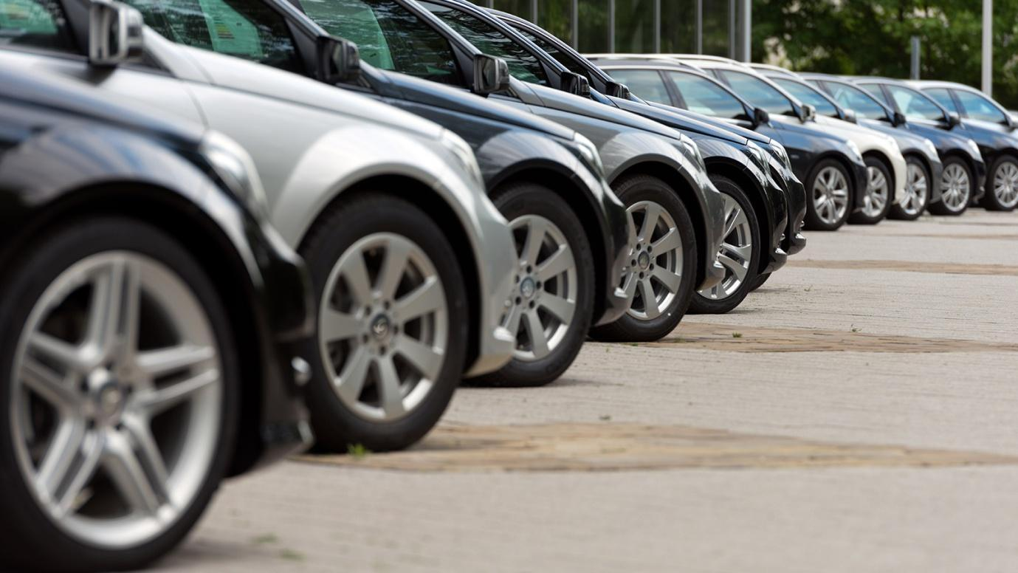

**By**

**Team- S3**

**Deepam Khirwar**

**Harshita Didwania**

**Kavindu Walimunige**

**Sanchit Singh**

**Sathiya Priya Jeevanandan**



**Sequence Diagram**

**Match Vehicles with Customer (On-Site)**

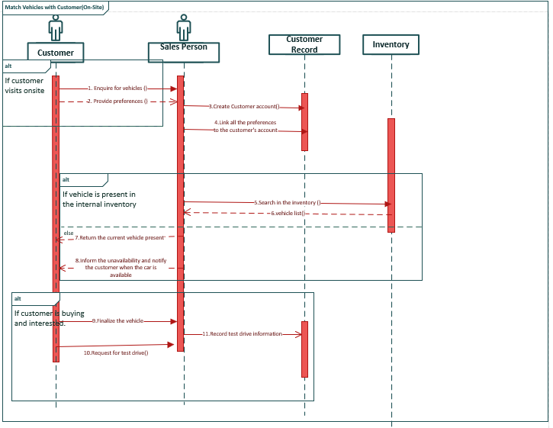

**Communication Diagram**

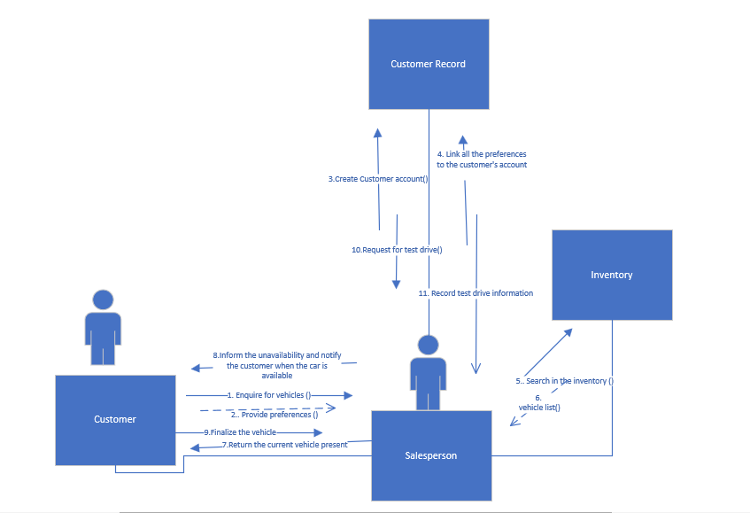

**Sequence Diagram for Sell Car**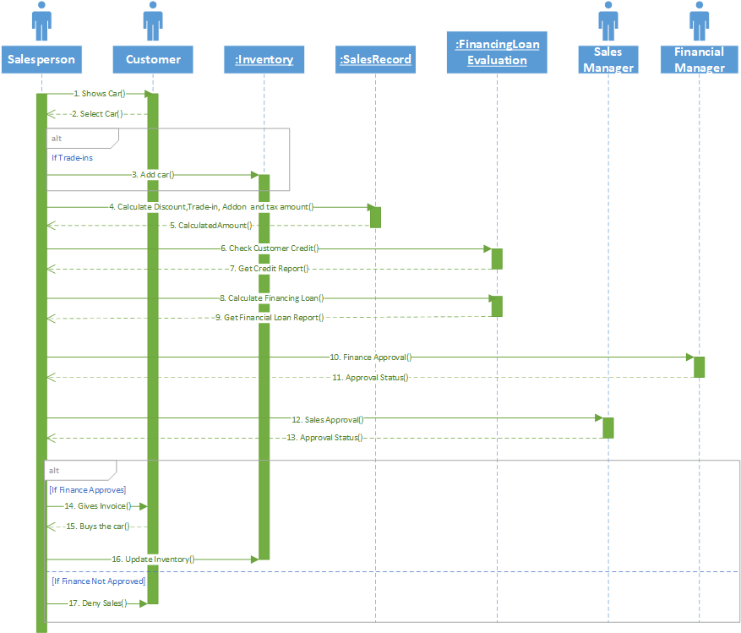

**Communication Diagram for Sell Car**

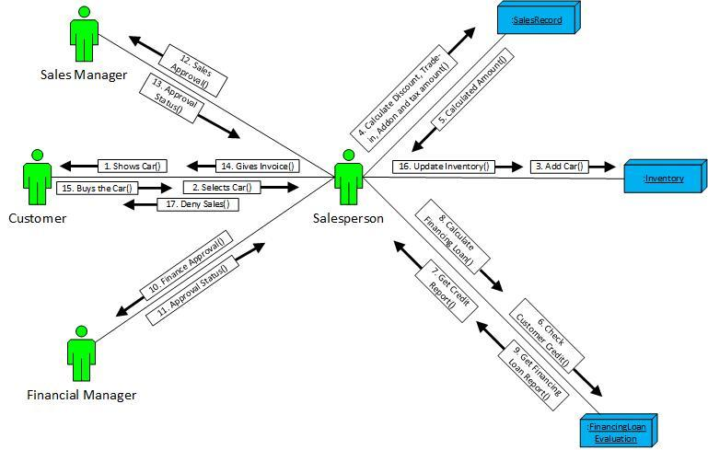

**Managing Inventory**

**Sequence Diagram**

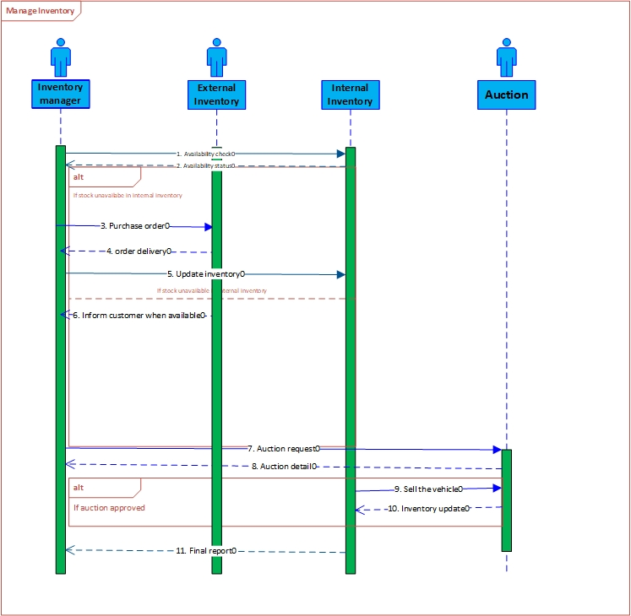

**Managing Inventory**

**Communication Diagram**

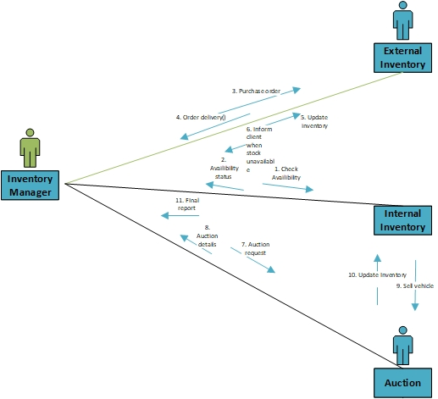

**Calculating Sales Commission**

**Sequence Diagram:**

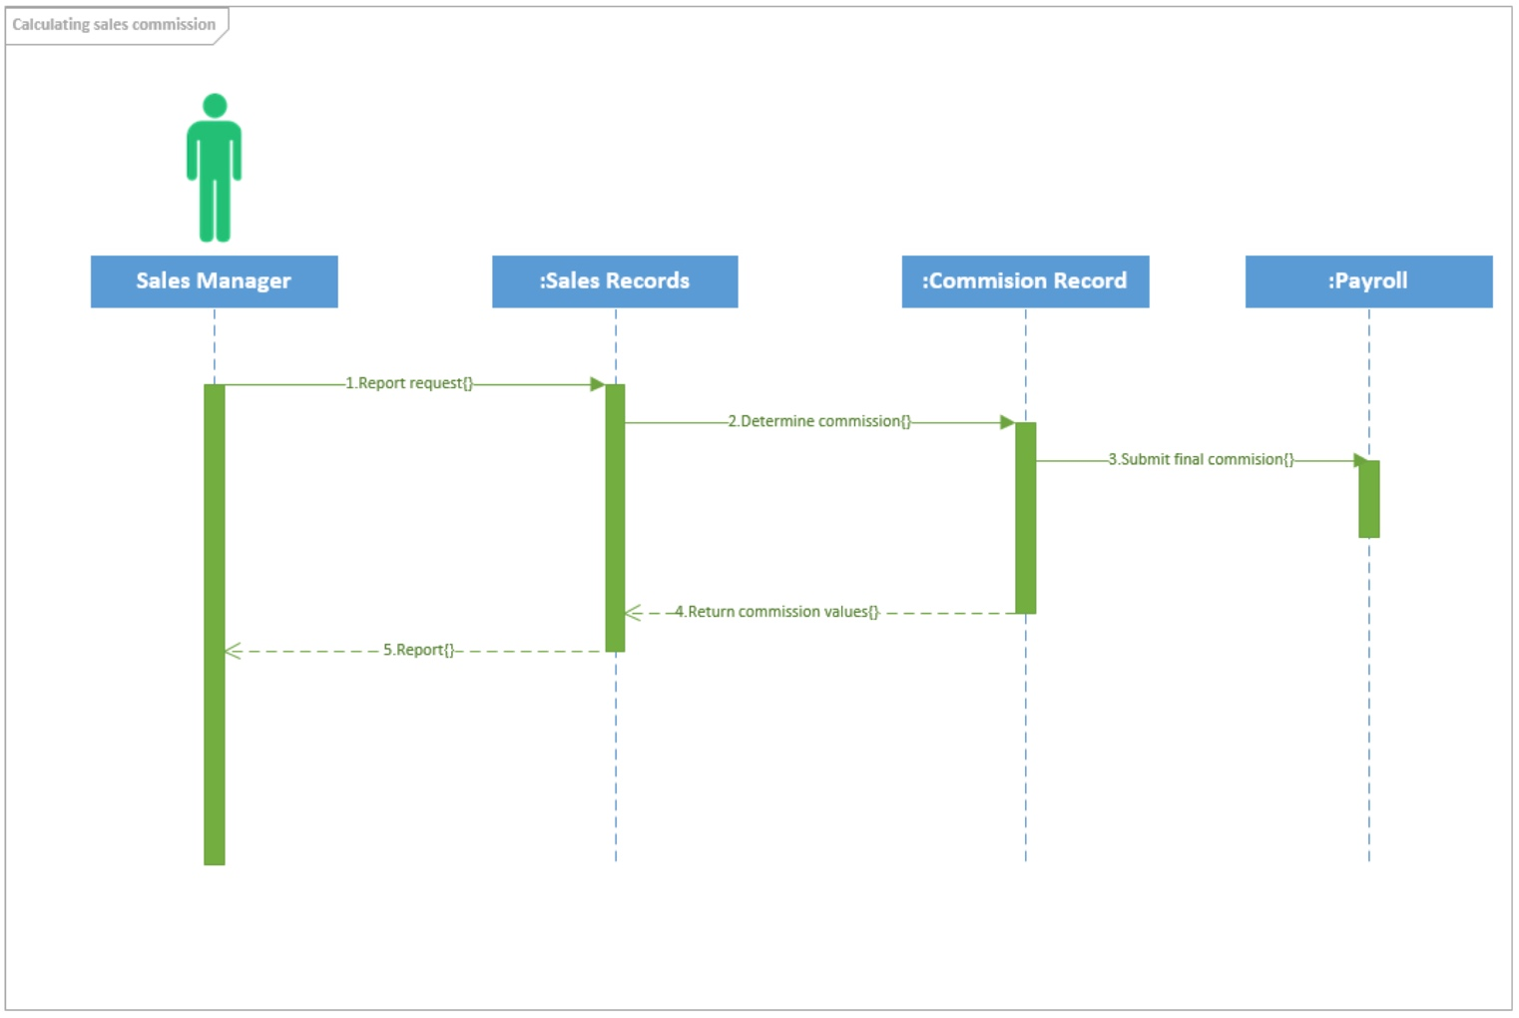

**Calculating Sales Commission**

**Communication Diagram:**



:Sales Records

:Commission Records

:Payroll

Report request

1.2. Report sent

Sales Manager

2.2. Returned values

2.1. Calculated Commission request

3. Final Commission Amount request

**Identify Promotional offer**

**Sequence Diagram**

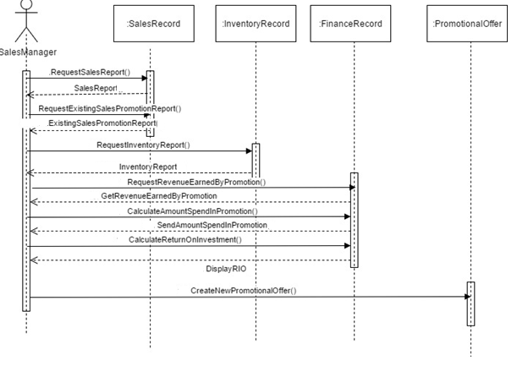

**Communication Diagram**

